**TASK # 1:**

NAME: MUHAMMAD ABUBAKR

ROLL NO: 25K-0503

PROGRAM:

OUTPUT:

**TASK # 2:**

PROGRAM:

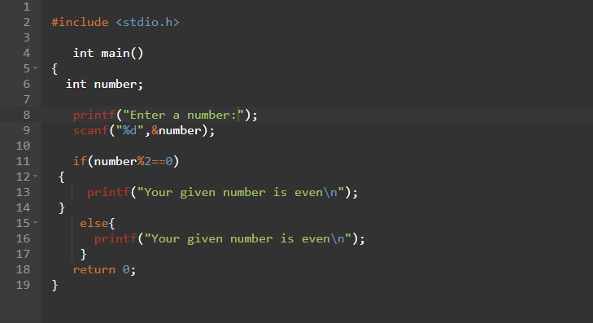

OUTPUT:

**TASK # 3:**

PROGRAM:

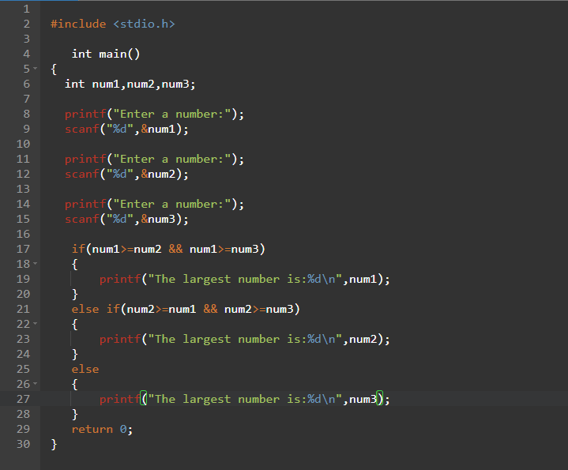

OUTPUT:

